**Book of Words**

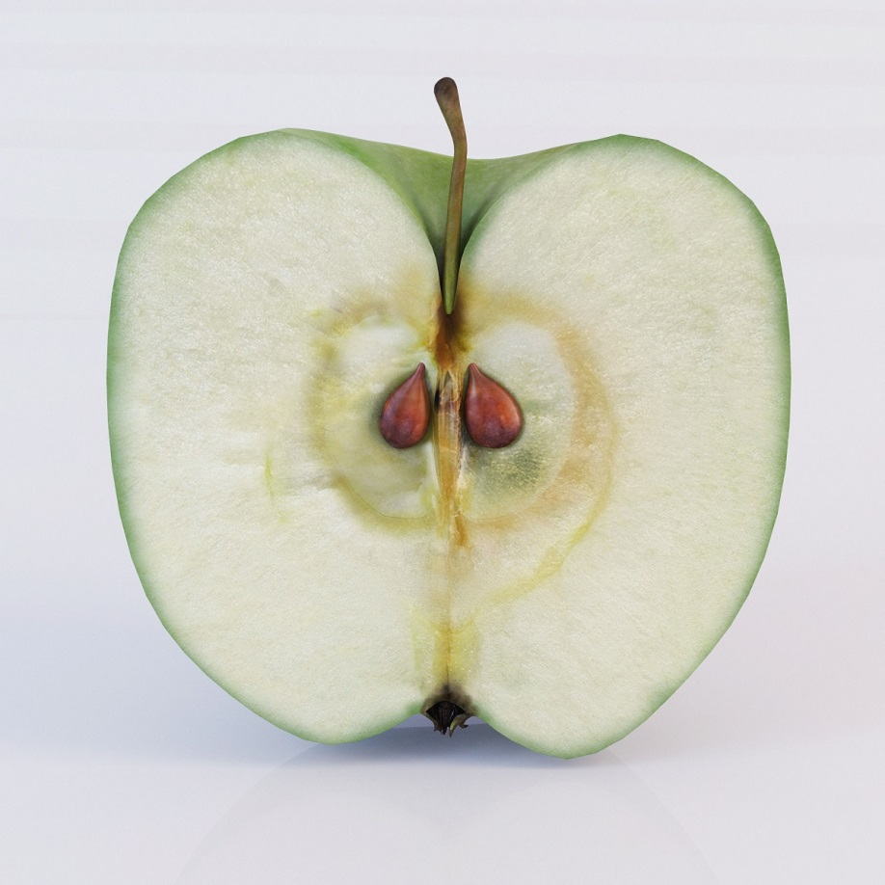

**Apple Fruit Eat**

**Stem, seed, peel**

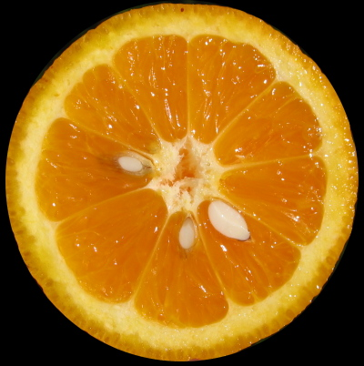

**Orange Fruit Eat**

**Seeds, Peel**

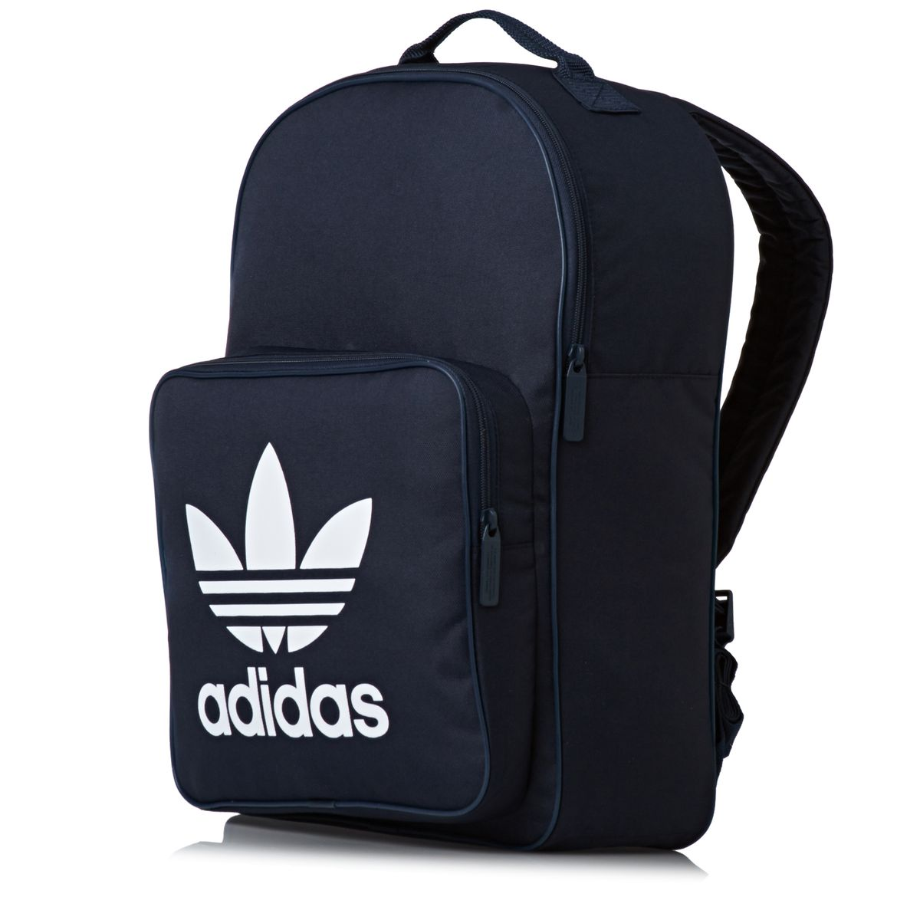

**Backpack Bag Put things in it (books, binders, clothes)**

**Zipper, straps, Pocket**

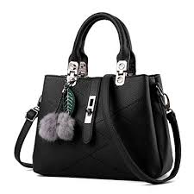

**Purse Container Put things in it (phone, wallet, keys)**

**Strap, handle, zipper, clasp**

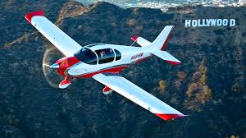

**Airplane Vehicle Takes people places**

**Wing, tail, cockpit**

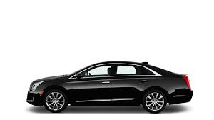

**Car Vehicle Takes people places**

**Wheels, hood, engine**

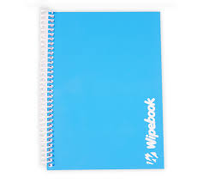

**Notebook School supply Draw and write in it**

**Paper, binding, cover**

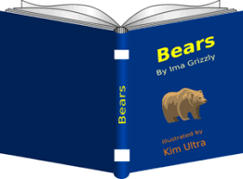

**Book School supply Read**

**Cover, pages, title**

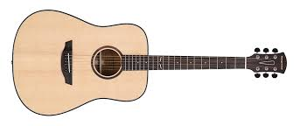

**Guitar Musical Instrument Play songs**

**Strings, keys, neck, bridge, body**

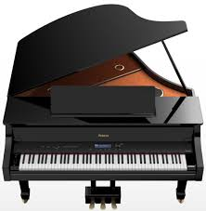

**Piano Musical Instrument Play**

**Keys, pedals, strings, lid**

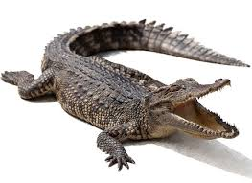

**Alligator Animal Eat meat**

**Tail, teeth, big jaw, legs**

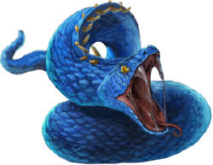

**Snake Animal Eat animals whole**

**Teeth, Venom, tails,**

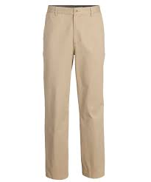

**Pants Clothing Wear**

**Waistband, belt loops, zipper**

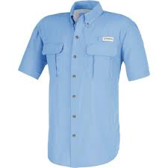

**Shirt clothing wear**

**Collar, buttons, sleeves**

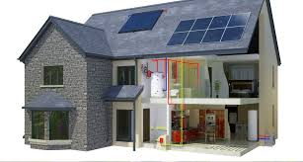

**House building live in it**

**Door, roof, rooms**

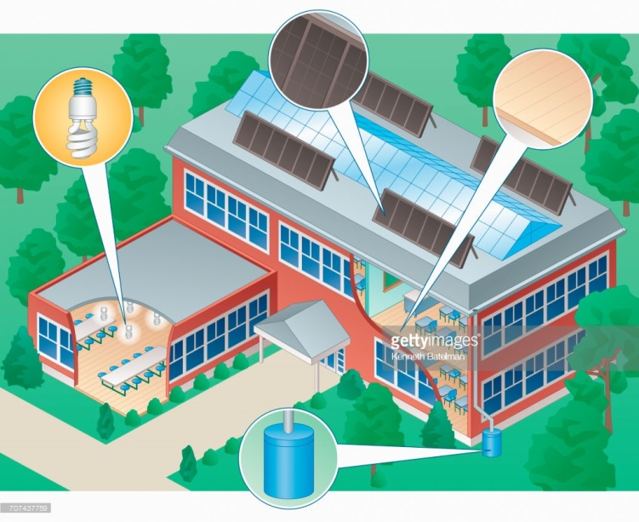

**School building learn there**

**Door, roof, classroom**

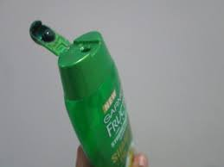

**Shampoo cleaner wash hair**

**Bottle, flip top, fruity or floral smell**

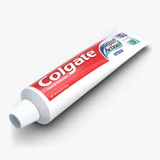

**Toothpaste cleaner clean teeth**

**Tube, screw cap, minty**

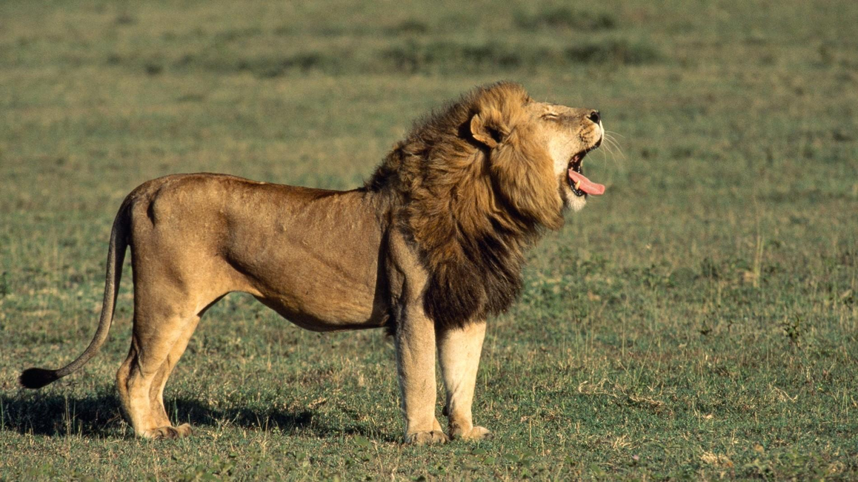

**Lion animal eats meat**

**Mane, teeth, fur**

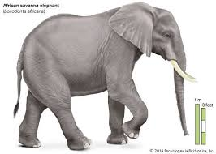

**Elephant animal eats leaves**

**Trunk, tusks, hair**

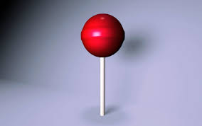

**Lollipop candy eat/lick**

**Stick, sticky, sweet**

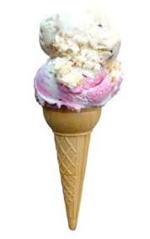

**Ice cream cone dessert eat/lick**

**Cone, scoop, cold**

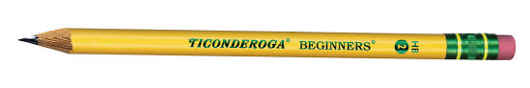

**Pencil, school supply, write/draw**

**Eraser, lead, point**

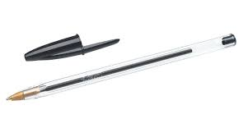

**Pen, school supply, write**

**Cap, point, ink**

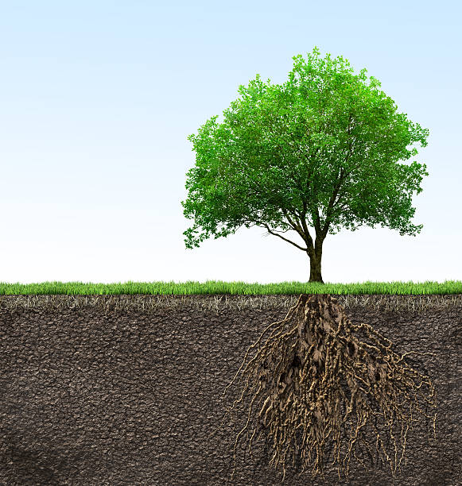

**Tree plant wood/oxygen/decoration**

**Trunk, branches, roots**

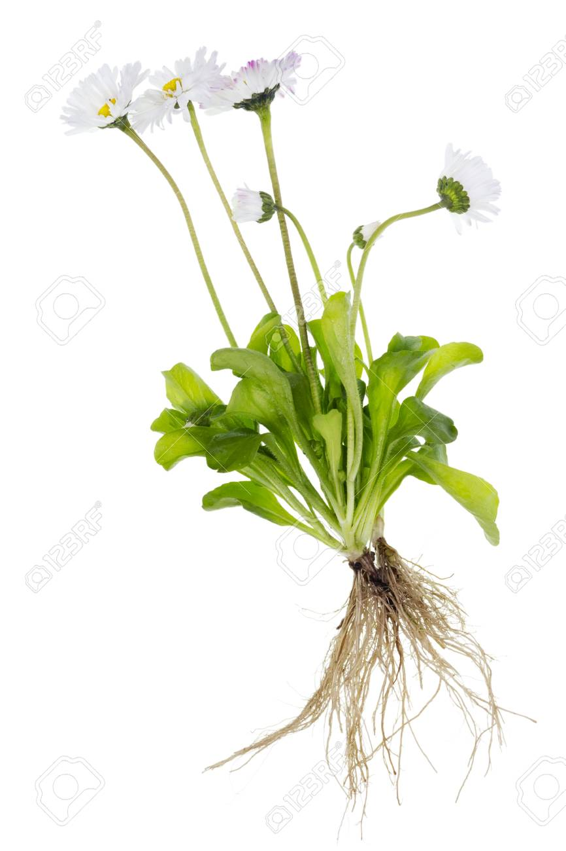

**Daisy plant decoration**

**Flower stem roots**

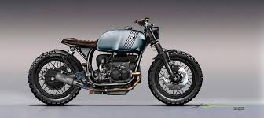

**Motorcycle vehicle ride**

**Handlebars, two wheels, motor**

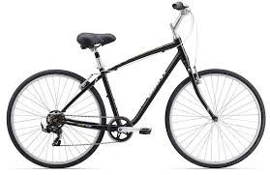

**Bicycle vehicle ride**

**Handlebars, two wheels, pedals**

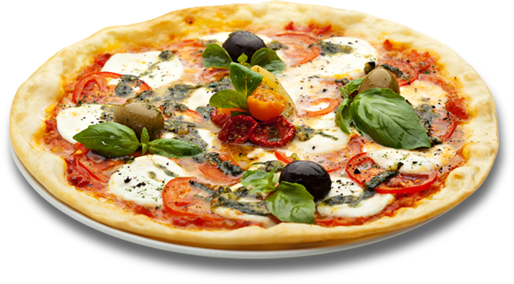

**Pizza food eat**

**Crust, sauce, toppings**

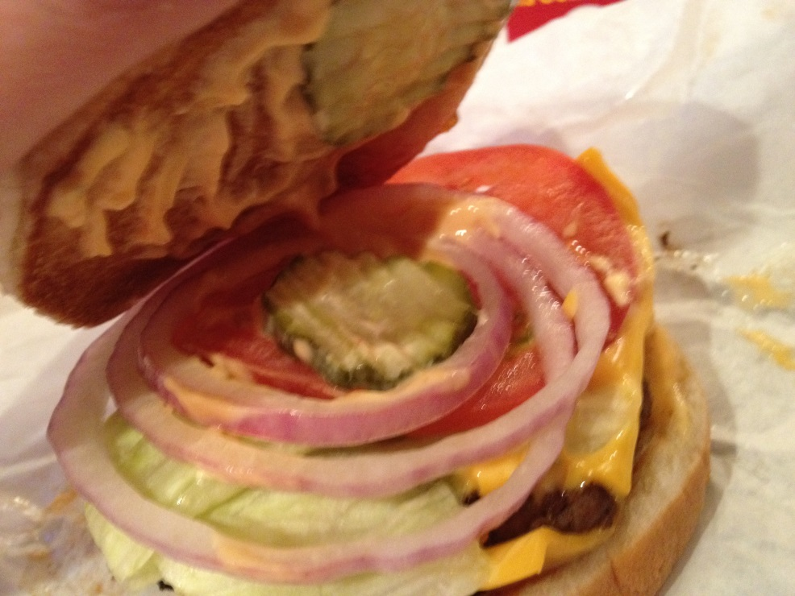

**Cheeseburger food eat**

**Bun, patty, cheese**

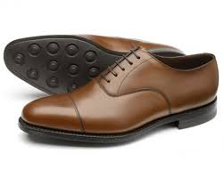

**Shoes clothing wear on feet**

**Sole, toe, heel**

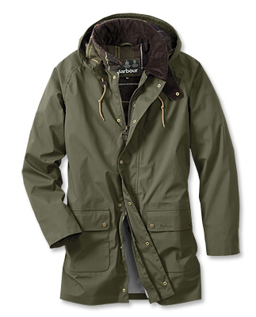

**Coat clothing wear**

**Hood zipper pockets**

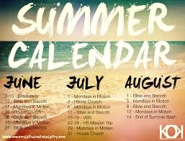

**Summer season measures the year**

**Hot no school July,August**

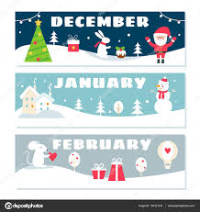

**Winter season measures the year**

**Cold, snow January, February**

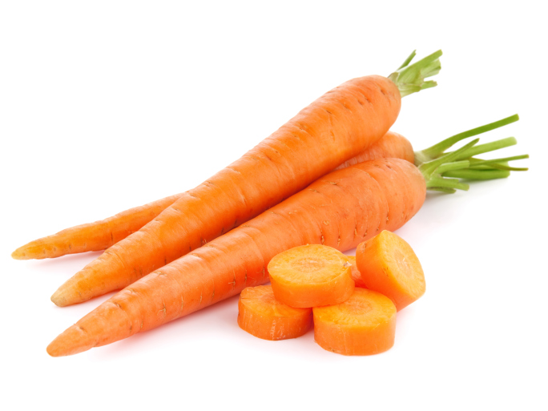

**Carrot vegetable eat**

**Top, orange, root**

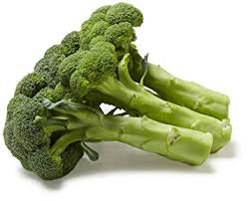

**Broccoli, vegetable, eat**

**Stalk, flowers, green**

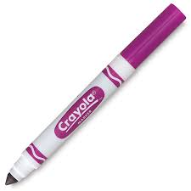

**Marker school supply write/draw**

**Cap point ink**

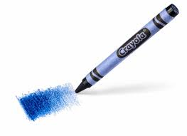

**Crayon school supply write/draw**

**Point, wrapper, wax**

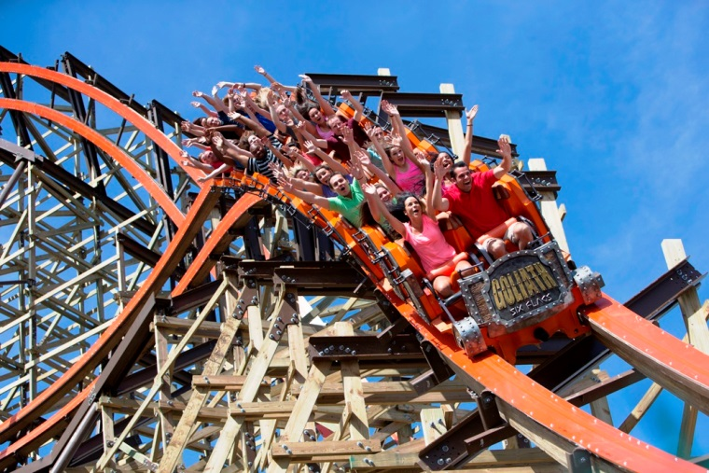

**Roller coaster ride entertains**

**Tracks, cars, seatbelt**

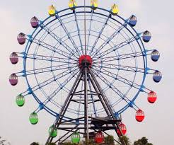

**Ferris wheel ride entertains**

**Wheel, cabins/cars, spokes**

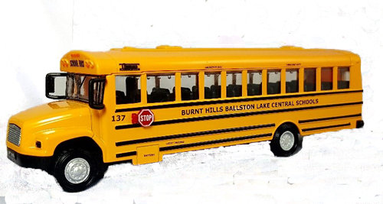

**Schoolbus vehicle transport students**

**Yellow seats stop sign**

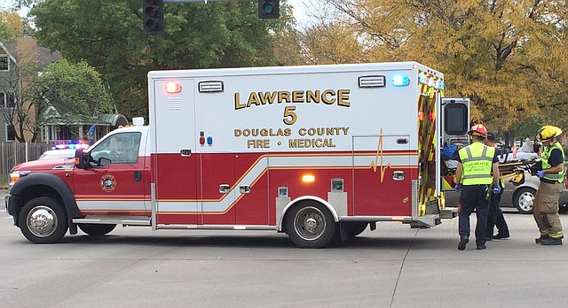

**Ambulance vehicle transport sick people**

**Siren lights stretcher**

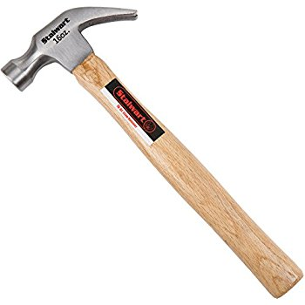

**Hammer tool pound nails**

**Handle head claw**

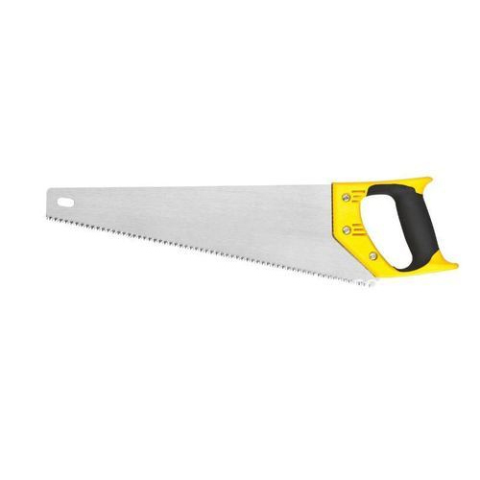

**Saw tool cut wood**

**Handle blade teeth**

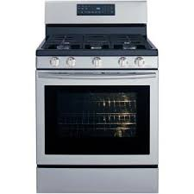

**Stove appliance cook**

**Oven burners knobs**

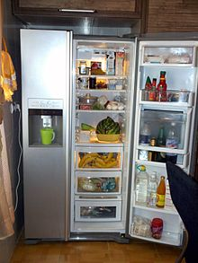

**Refrigerator appliance store food**

**Freezer shelves icemaker**

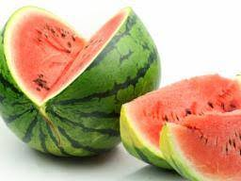

**Watermelon fruit eat**

**Rind, black seeds, red flesh**

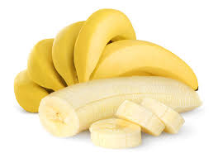

**Banana fruit eat**

**Peel, seeds, bunch**

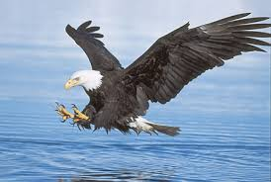

**Bird animal flies**

**Beak wings talons**

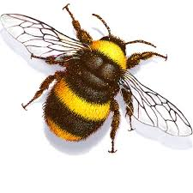

**Bee animal flies/pollenates**

**Wings, antennae, stinger**